**Host ASP.NET Website from Visual Studio**

**Step 1:** Open Windows Azure Management Portal & select “WebApps”.

**Step 2:** Create New Website

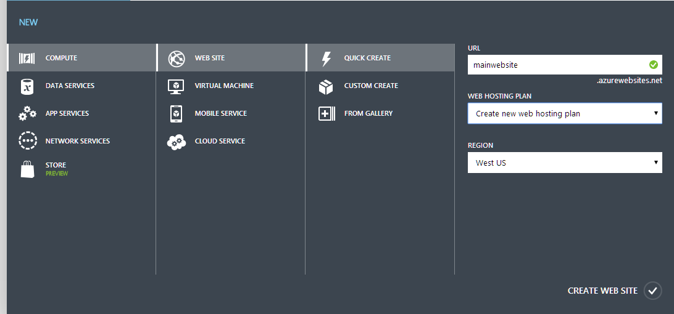

**Step 3:** Open website and click on “DASHBOARD”.



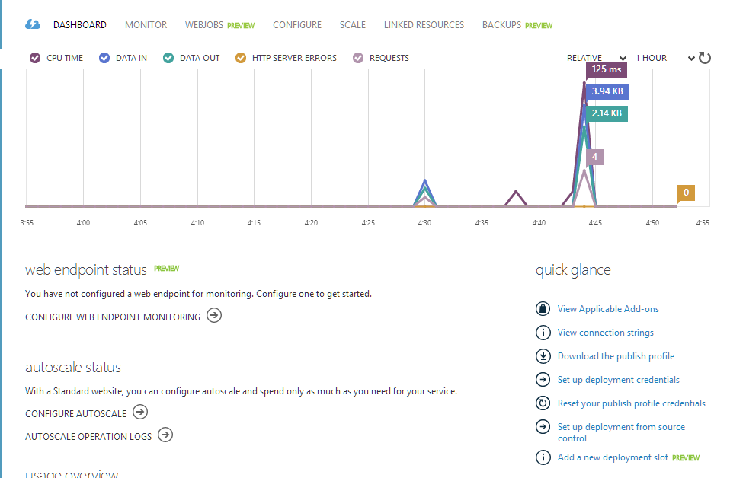

Download the publish profile.

**Step 4:** Open website in Visual Studio

Right click on the website & select “Publish…”

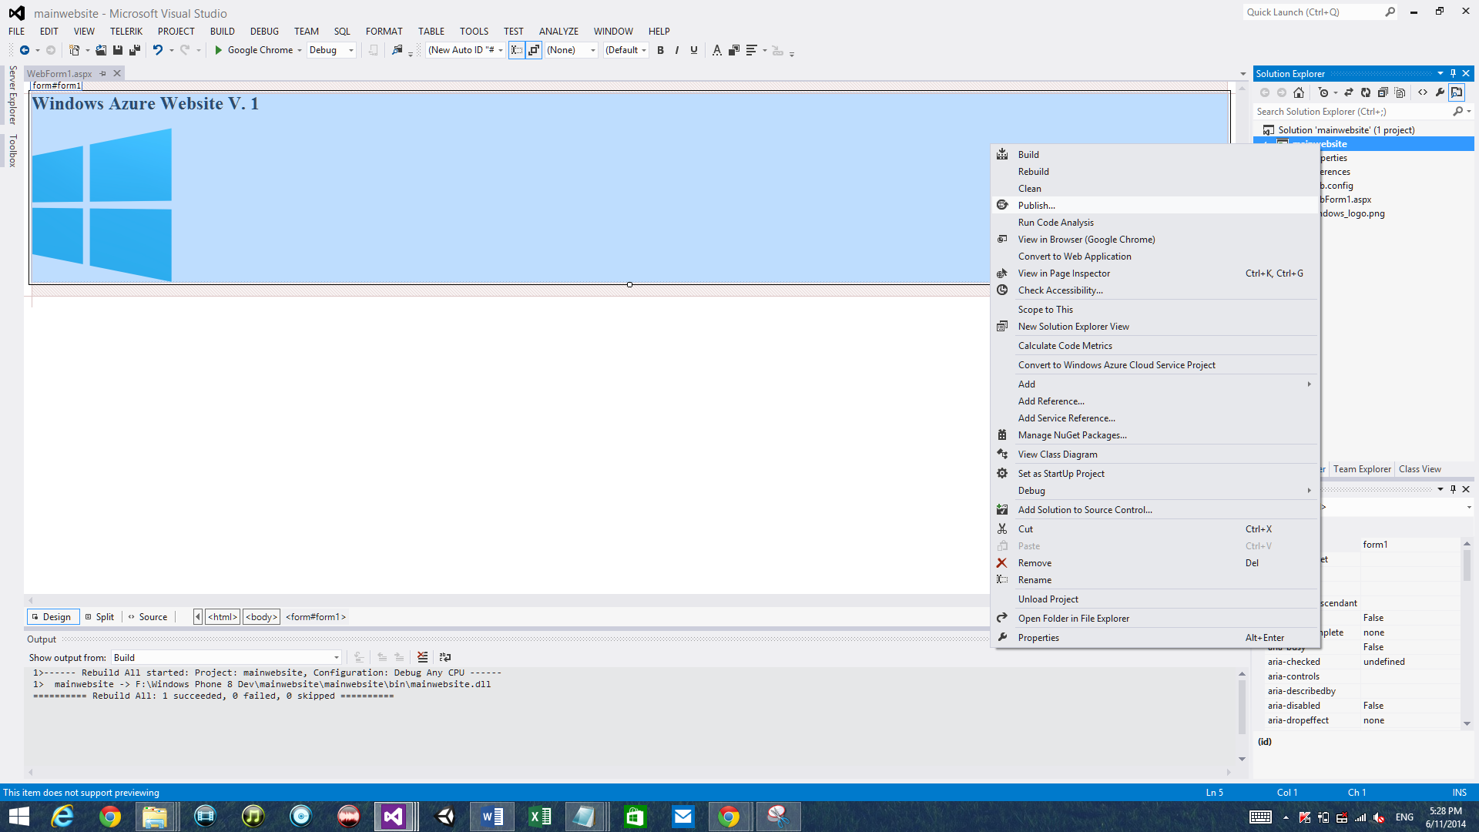

**Step 5:** Select “Import” option

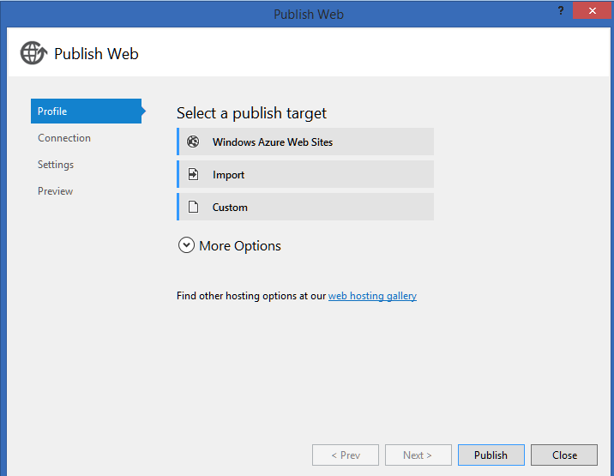

Browse the publish profile

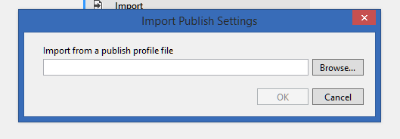

Select website publish profile

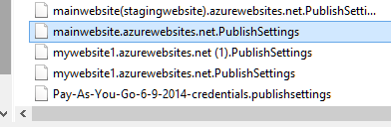

Click on Next button

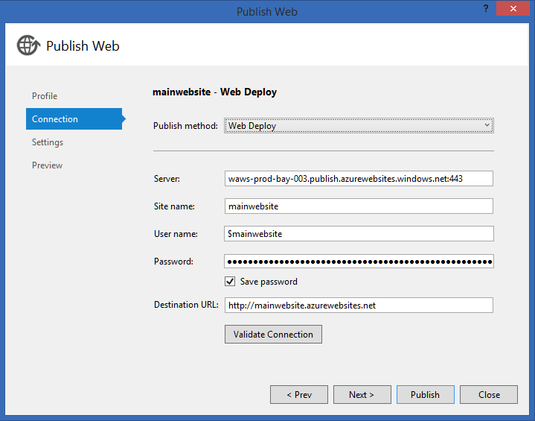

Again select Next button.

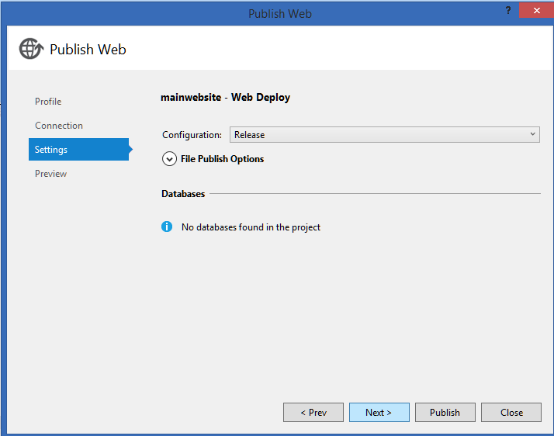

Again select Next button & last select Publish button.

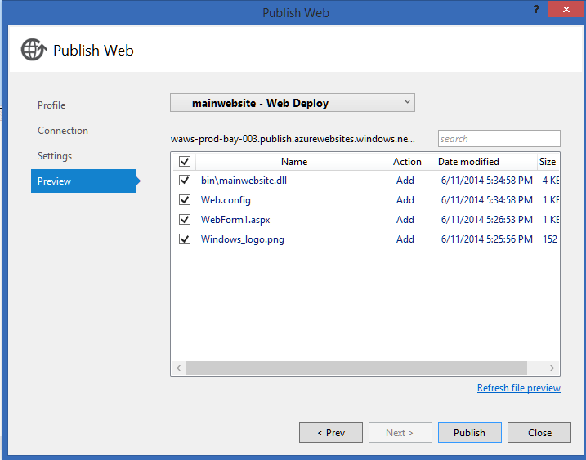

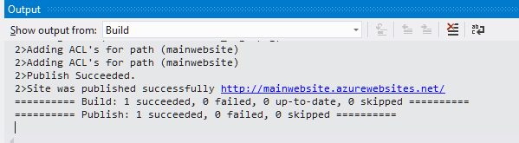

Now open the URL.